The Teresa Lozano and Joe R. Long Center for the Performing Arts.
Debra and Kevin Rollins Studio Theatre
Technical Specifications
For questions concerning techincal specification and execution please contact:
Production Supervisor - Chris Braudt Email: Cbraudt@thelongcenter.org

Contents
Seating and House Capacity 1
Lighting 3
Projection 4
Audio 6
Stage Area Power 7
Rollins Studio Theatre Area Floor Plan 9
Rollins Studio Theatre Photos 10

Seating and House Capacity
The Debra and Kevin Rollins Studio Theatre, with its flexible black-box style seating configurations, may be used in a variety of configurations, with Wenger portable seating, for a fee. If you are interested in reconfiguring the seating unit in the Rollins Studio Theatre, please inquire with the Long Center’s Production Department for a quote. Upon rental of the Debra and Kevin Rollins Studio Theatre, the seating will be set up in the standard 138 seat configuration. There are doors located in each of the four corners of the room which provide performers and patrons with multiple entrances into the performance space. Additionally, a double door on the wall opposite of the control booth allows for scenery and equipment to be easily accessed from the backstage area. Wheelchair and ADA access are available in all seating configurations. Assistive listening devices are available upon request.

Standard Configuration: 138 seats
Maximum Seating Capacity: 229 seats
For Seating Configuration options and diagrams, please contact the Production Supervisor.
The Rollins Theatre must be restored to the standard 138 seat configuration if changed.

ADA Complient
The theatre's floor level and control booth are ADA accessible. ALD (assistive listening devices) is available upon request.

Room Specifications
Dimensions: 60’ x 46’-0”
Floor to Catwalk Height: 20’-0”
Control Room Dimensions: 26’-6” wide x 10’-8” deep

Catwalks
There are five rows of catwalks spanning over the Rollins Theatre; each is 3’-2” wide

Stage Floor
The stage floor, in order of constructions includes a resilient rubber vapor barrier, sleepers, 2 layers of ¾” plywood, and topped with ¼” Masonite. Drawings available upon request

Loading Access
The loading door is 8’-0” wide by 8’-0” tall.
The door from the loading area into the theatre is 7’-6” wide by 6’-10.5” tall.
The loading door is located on the east side of The Long Center. There is no loading dock on the stage floor level. A lift gate is required to unload heavy boxes and items into the Rollins Studio Theatre.

Dressing Rooms
There are two dressing rooms for the cast and crew. These dressing rooms will accommodate 10 people each. Both are equipped with Clear-Com wall panels and video monitors (displaying FOH video shot). The Clear-Com panels can receive page announcements from the Stage Manager as well as “program” audio from the theatre's house mic.

Greenroom
A greenroom/lounge for performers is available in the backstage area equipped with kitchen sink and mini fridge. (Please no cooking on site)

Laundry Rooms
Laundry facilities are available in the backstage area. There is one household size washing machine and one household size dryer. (1x) Steamer, (1x) Iron/Ironing Board, and (3x) Z-racks

Soft Goods:
Amount Item Size Material & Notes
8 | Legs | 12’-0”w x 19’-0”h | 25oz Velour Sewn Flat w/ Grommets & Ties
2 | Legs | 10’-0”w x 19’-0”h | 25oz Velour Sewn Flat w/ Grommets & Ties
1 | Borders | 44’-0”w x 6’-0”h | 25oz Velour Sewn Flat w/ Grommets & Ties
1 | Traveler | 2 panels; each 22’-0”w x 20’-0”h | 25oz Velour; w/ Traveler Track, & Pulley
1 | Black Scrim | 38’-0”w x 19’-0”h | Black Sharkstooth Scrim w/ Grommets & Ties
1 | White Scrim | 38’-0”w x 19’-0”h | White Sharkstooth Scrim w/ Grommets & Ties
2 | White Cyc | 38’-0”w x 19’-0”h | White Muslin w/ Grommets & Ties

Lighting
The Debra and Kevin Rollins Studio Theatre is equipped with 2400-Watt high rise dimmers dedicated to the house light circuits. There is a house “rep” plot – this plot may be changed but must be restored at the end of the engagement. Plot available upon request. The following equipment is currently in inventory; The Long Center makes no guarantees as to future availability.

Control
1 | ETC ION – 4 DMX 512 universes, with a 40 fader expansion wing
184 | 2400-Watt Standard ETC Sensor Dimmers
4 | 6000-Watt Standard ETC Sensor Dimmers
21 | 2400-Watt Non-Dim Circuits
6 | Portable 2-Port ETCNet2 DMX Nodes for DMX Output/Input
1 | Wireless Remote Focus Unit
1 | iPad Mini w/ ETC Remote Focus App

Fixture Inventory
78 | Source Four ERS Bodies w/ 750-Watt Lamp
6 | ETC 19-Degree Source Four Lens Tubes
24 | ETC 26-Degree Source Four Lens Tubes
42 | ETC 36-Degree Source Four Lens Tubes
12 | ETC 50-Degree Source Four Lens Tubes
12 | ETC 15-30 Degree Source Four Zoom ERS w/ 750-Watt Lamp
12 | ETC 25-50 Degree Source Four Zoom ERS w/ 750-Watt Lamp
24 | ETC Source Four PAR w/ 750-Watt Lamp
10 | Altman Spectra Cyc 200
6 | SeaChanger Color Mixing Units in 36-degree Source Four w/ 750-Watt Lamp*
* Manufacturer’s website about this product: http://www.seachangeronline.com/profile.html

Lighting Positions and Circuits
The handrails of the catwalks are the only permanent lighting positions in the theatre. Additional lighting pipes may be dead hung in virtually any position.

All circuits terminate in stage pin connectors. Non-dim circuits are relay-switched, suitable for powering motors and moving lights at 120v.

At the catwalk level there are 152 @ 20A circuits, 4 @ 50A circuits and 16 @ 20A non-dim circuits. Additional circuits are available at or near the stage in the following locations:

Location # of lighting circuits
North Wall | 6 @ 20A, 1 @ 20A non-dim
East Wall | 9 @ 20A, 1 @ 20A non-dim
South Wall | 6 @ 20A, 1 @ 20A non-dim
West Wall | 9 @ 20A, 1 @ 20A non-dim
Backstage Area | 2 @ 20A, 1 @ 20A non-dim

Lighting Network and DMX distribution
Ethernet ports for access to the ETCNET lighting network are distributed throughout the theatre. All data distribution is via the lighting network; there are no DMX dry lines in the facility. To protect the integrity of the lighting system, only approved equipment may be connected to the lighting network.

Cue Light System
(1x) Leon Audio 14-channel master control unit located in the control booth
(6x) Leon Audio QLS-B Mk3 cue light station

3pin Connection jacks for cue light stations are available throughout the theatre.

Projection

The following equipment is currently in inventory; The Long Center makes no guarantees as to future availability.

Projector
Model
Manufacturer
Amount
Description
Panasonic
PT-RZ870BU

1
8.5
k Lumen DLP Projector.

Inputs:
VGA In (Dsub-15pin), DVI

Digital Input, RGB In
BNC), HDMI, Network (RJ-45), RS232
(
(
DB-9pin), HD-SDI (BNC), VGA Ou
t
(
Dsub-15pin
)

Resolution: 1920x1200

Projection Screen
Amount | Manufacturer | Model | Description
1 | DA-LITE | Professional Electrol | Motorized projections screen. Permanently mounted to the south wall at catwalk level.  Screen is 16’x21’.

Audio

Variable Acoustics
The Debra and Kevin Rollins Studio Theatre is equipped with a variable acoustic system using tracked, “walk-along” style variable acoustic curtains. This enables the room to become more ‘live’ or ‘dead’ depending on the needs of the event. All curtains are 25 oz. velour with 100% fullness. The following equipment is currently in inventory; The Long Center makes no guarantees as to future availability.

Loudspeakers/Amplification
All loudspeakers in the Rollins Studio Theatre are manufactured by Eastern Acoustic Works (EAW). The components are portable and may be set up according to the configuration of the performance space. The system uses various models of QSC amplifiers. Some of the speakers (indicated below) are hung in a “rep” plot configuration; these speakers can be moved but must be restored to their “rep” positions after the engagement.

Location Quantity Speaker Model Amplifier Model
Portable (hung in “rep” position) LR | 2 | EAW KF300isr Full Range Cabinet | QSC CX702
Portable | 4 | EAW SBX200 Subwoofer | QSC CX902
Portable | 4 | EAW SM129z Monitor Wedge | QSC CX702
Portable | 2 | EAW JFx290 Full Range Cabinet
Portable | 4 | EAW JFX88 Full Range Cabinet | QSC CX702
Portable (hung in “rep” position) Cntr | 1 | EV Xi-1082 | QSC CX702

Available Amplifiers
Amount Manufacturer Model Description
2 | QSC | CX702 | 2-Channel Power Amplifier. These amps can be used for EAW speakers: JFX290, SM129z, JFX88, & EV Xi-1082.  425W @ 8Ω. 700W @ 4Ω.
1 | QSC | CX902 | 2-Channel Power Amplifier. These amps can be used to power the EAW subwoofers, SBX200.  550W @ 8Ω. 900W @ 4Ω.

House Mixing Console
Amount Manufacturer Model Description
1

Allen & Heath
GLD-112
16
DCA/mute group, 4 xlr mic/line
inputs/outputs, 4 RCA
input/output, 48 input channels,
30
buses into 20 mix outputs

Outboard Equipment
Amount | Manufacturer | Model | Description
1 | Allen & Heath | GLD-AR2412 Audio Rack | 24 input channels x 12 outputs expander audio rack
2 | Allen & Heath | GLD-AR84 Audio Rack | 8 input channels x 4 outputs expander audio rack

Theatrical Intercom
The Rollins Theatre has a built-in four-channel Clear-Com system with hard wired connections in all production and backstage areas. There are no in-house options for Wireless Com at this time.

Amount Manufacturer Model Description
4 | Clear-Com | RS-601 | Wired Belt Pack
2 | Clear-Com | CC-260 | Headset – Double Muff
4 | Clear-Com | CC-95 | Headset – Single Muff

Microphones and Direct Input Boxes (prior advancement required)
Amount Manufacturer Model Description
4 | Shure | SM57-LC | Dynamic Instrument Microphone
4 | Shure | SM58-LC | Dynamic Vocal Microphone
4 | AKG | 535EB | Condenser Microphone
2 | Shure | Beta 87C | Condenser Vocal Microphone
2 | BSS | AR-133 | Active Direct Box

Ancillary Equipment
Amount | Manufacturer | Model | Description
2 | Whirlwind | MS-12-0-NR-050-SS | Microphone Sub Snake
2 | Ultimate Support | TS-99B | Speaker Stands
6 | Atlas Sound | - | Straight Mic Stand

Additional Audio Items available for rent.
Inquire with The Long Center’s Production Department for current rental fees

Amount Manufacturer Model Description Cost
1 | Shure | AD4D Wireless Receiver | Dual Channel G57 band Receiver | -
2 | Shure | AD1 Beltpack Transmitter | Transmitter  with MKE2 Lavaliere Mic | P/U- $55/day $100/Week
2 | Shure | AD2 Handheld  Transmitter  (58,87) | Handheld sm58  Mic with built-in Transmitter | P/U- $55/day $100/Week

Stage Area Power

All connections and disconnections to these panels must be performed by house personnel. Nominal voltage is 120/208v 3 phase, 60Hz. All Cam-Lock for lighting power connections have neutral and ground reversed. The company switches for Audio power do not have neutral and ground reversed; they are Pin and Sleeve connections.

Company Switches
Amperage Location Connection Type Notes
100 Amps | Rollins Backstage Area | Cam-Lok; Panel with Stage Pin and Edison on Wall | 8 @ 20A stage pin,  8 @ 20A edison
100 Amps | Southwest Catwalk Level | Cam-Lok
60 Amps | Rollins Backstage Area | 60 Amp Pin and Sleeve* | Isolated Ground, Audio Only

Amount Manufacturer Part # Description
1 | Leviton | Connectors are 560P9W | 50’ 60-Amp Pin and Sleeve Cable
1 | Union Connector | 56DBT-06122U-IG | 60-Amp Pin and Sleeve Breakout Box with 12 circuit breakers with 2 Edison connectors each.

Theatrical Audio Power
In the Rollins Studio Theatre, there are numerous power outlets with orange Edison connectors. These have an isolated ground specifically for audio equipment. They should only be used for such. These outlets are also connected to the audio sequencer, which must be powered on at the audio rack to energize the outlets.

Theatrical Lighting Control Power
In the Rollins Studio Theatre, there are a few power outlets with blue Edison connectors. These are on the same power conditioner UPS as the lightboard and should only be used for lighting control equipment.

Rollins Studio Theatre Area Floor Plan
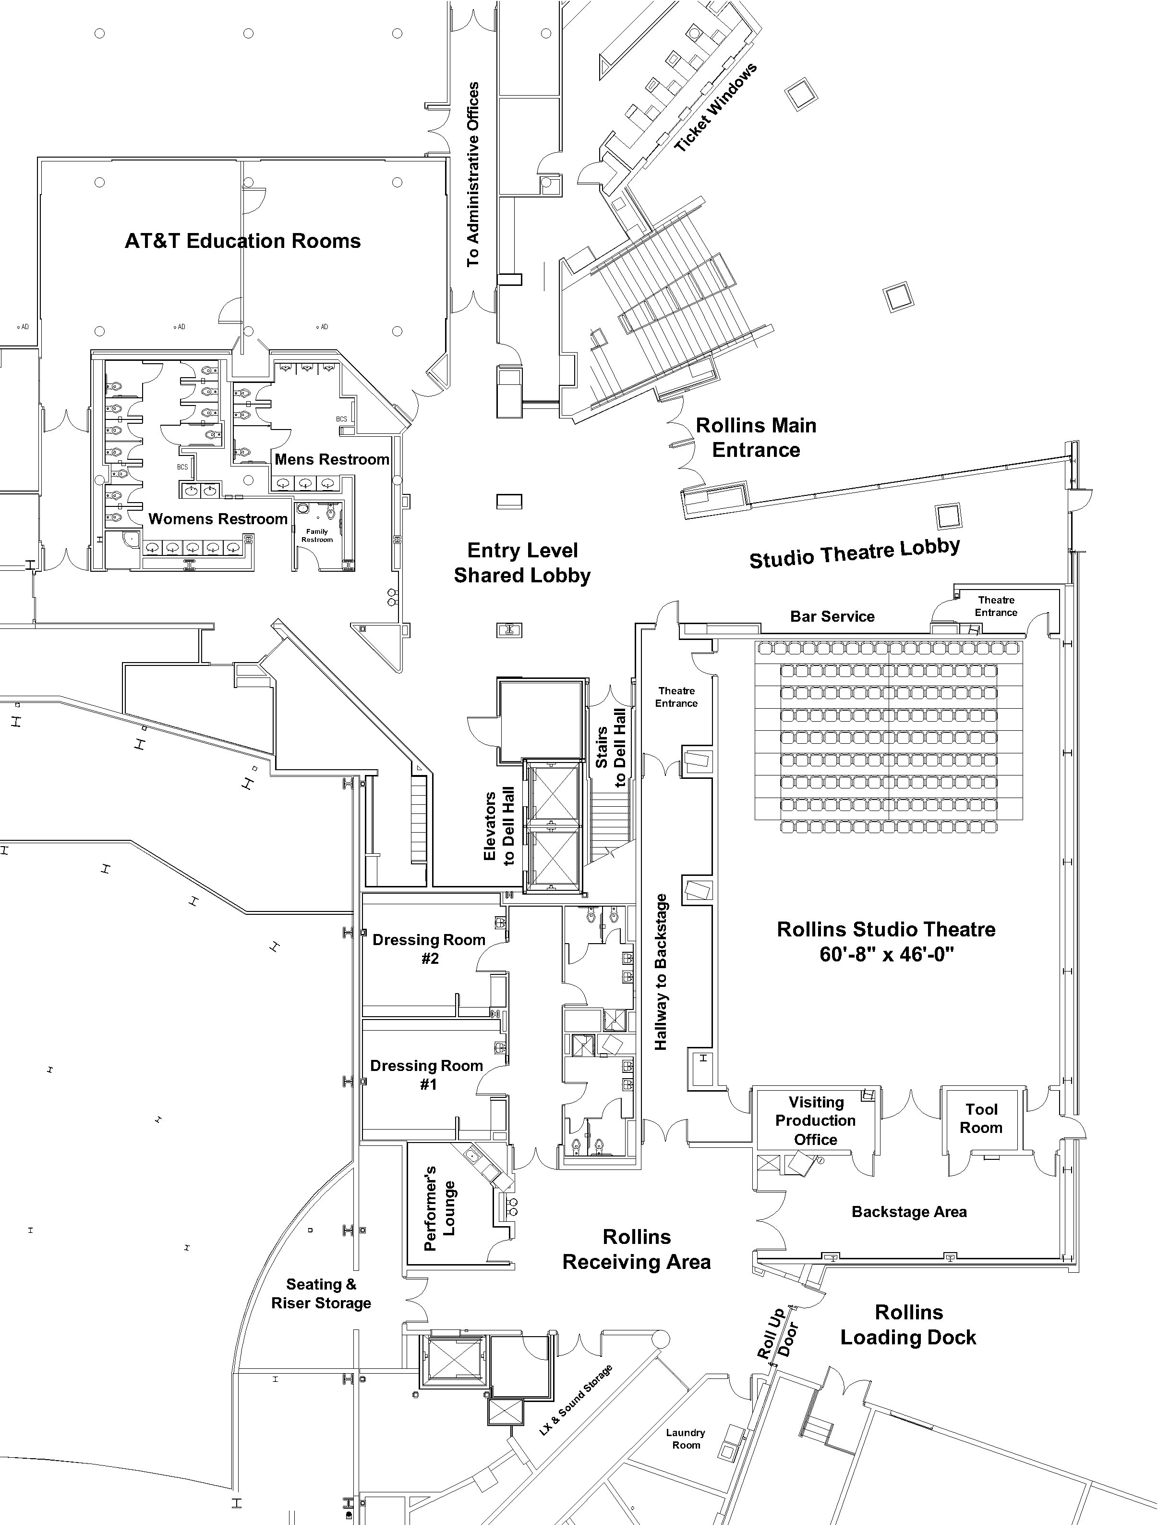
Drawing Not to Scale

Rollins Studio Theatre Photos

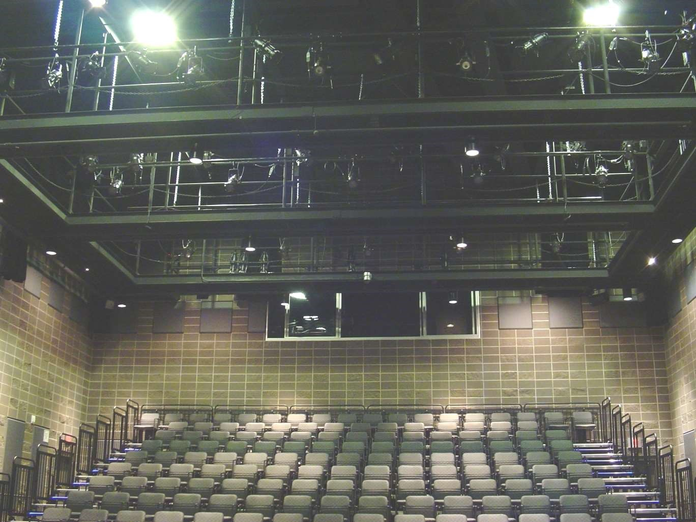
End Stage Medium Seating Configuration from the loading doors

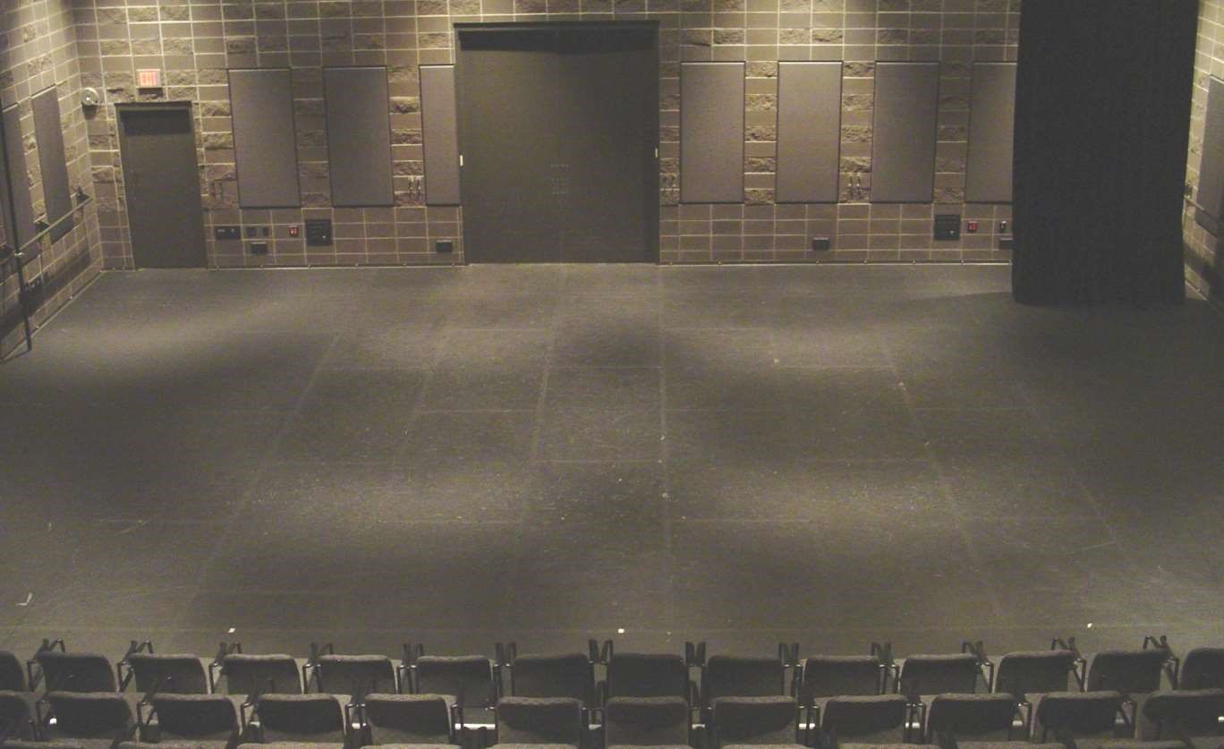

Rollins End stage Medium Seating Configuration View from the Tech Booth

Rollins Studio Theatre Loading Dock
